

Revision: Date:

1.0 15/10/2021

Title:

**USER MANUAL – FIR Filter on FPGA**

Author(s):

**Thomas Overmeire (22255577)**

**Zicong Yan (22940392)**

**Jonathan Zhang (22941998)**

**Jonathan Louw (21712457)**

**Chang Li (22669058)**

**Bo Wang (22942279)**

Document History:

|  |  |  |  |  |
| --- | --- | --- | --- | --- |
| Revision | Date | Comments | Completed | Checked |
| 1.0 | 15/10/2021 | Document Completed | T.O. |  |
|  |  |  |  |  |

## Table of Contents

Table of Contents 2

1 Description of the User 3

2 Description of the Device 3

2.1 Purpose of Device 3

2.2 Technical Data 3

2.3 Product Elements 3

2.4 User Interface 4

3 Other Information 4

3.1 DE10-Lite Board Documentation 4

4 Safety Instructions 4

5 Installation 5

5.1 Connecting the DAC module 5

5.2 Connecting the wave generator and oscilloscope 6

6 Operation 6

6.1 Instructions for Use 6

6.2 Operating Environment 7

6.3 Stopping Operation 7

7 Maintenance 7

7.1 Replacing DAC 7

8 Troubleshooting 7

9 References 10

10 Appendix A – Generating Coefficients 11

# Description of the User

Users are mainly students and lab instructors participating in Digital System Design unit. Students need to use relevant equipment to complete the lab tasks in lab manual, lab instructors need to manage the equipment and assist the students to complete the lab tasks.

# Description of the Device

## Purpose of Device

This device is intended to take incoming data from a wave generator or similar electrical component through the ADC, filter it using the programmed FIR filter, and output the data from the DAC to an oscilloscope or other monitoring device. The device is intended to be programmed and tested in the assessment Laboratory 1 for the unit ELEC4406 in the University of Western Australia.

## Technical Data

The FIR coefficients were generated using the MATLAB Filter designer program. There are four filters: a high pass filter, a low pass filter, a band pass filter, and a band stop filter. The coefficients can be replaced by using the steps in Appendix A.

|  |  |
| --- | --- |
| Filter mode | Coefficient |
| High Pass | 0167 3dee 36fa 1310 36fa 3dee 0167 |
| Low Pass | 3ec2 038c 1200 1b12 1200 038c 3ec2 |
| Band Pass | 386d 33eb 0759 1852 0759 33eb 386d |
| Band Stop | 058f 0a3d 3a7a 1cc5 3a7a 0a3d 058f |

Table 1: Example coefficients of the FIR Filter

All other technical data can be found in the relevant manuals described in section 3.1.

## Product Elements

**DE 10 Lite MAX 10 FPGA board**

The FPGA used is the DE 10 Lite MAX 10 FPGA board. The DE10-Lite is an Altera MAX 10 based FPGA board. The board has the maximum capacity MAX 10 FPGA, which has around 50K LEs and ADC. It also has USB-Blaster, SDRAM, accelerometer, VGA output, 2x20 GPIO, and an Arduino UNO R3 expansion connector on a small board

**DAC**

The DAC used in this project is the Pmod DA2. The Pmod DA2 is a two-channel, 12-bit DAC converter, capable of achieving a resolution up to roughly 1mV and outputting data up to 16.5 MSa. The Texas Instruments DAC121S101 digital-to-analog converters power it. It has a 12-bit digital-to-analog converters and low power consumption. It uses a 6-pin Pmod header connector with a simple GPIO interface.

## User Interface

The wave generator output from the oscilloscope must be connected to the dedicated Arduino analogue input pin for channel zero of the ADC found on the bottom row of the Arduino pins, the right hand set of pins on the far-left side. The probe must be grounded, ground ports are marked on the FPGA Arduino pins, any can be selected. The output is observed via a second probe and is found by connecting the probe to the J2 port 6 on the DAC. The wave generator must have an offset of 2.50 Volts to observe the full waveform at the DAC. Channels on the oscilloscope must also be set to a ratio of 10:01 to observe the waveform correctly.

# Other Information

## DE10-Lite Board Documentation

The manual for the DE10-Lite Intel FPGA can be found at the following link: [1]

The manual for the InfiniiVision DSO-X 2002A oscilloscope and wave generator can be found at the following link: [2] This is just a reference, other oscilloscopes and wave generators will also work with this device.

The manual for the PmodDA2 Digital to Analog converter (DAC) can be found at the following link: [3]

# Safety Instructions

When entering the lab, you need to wear enclosed shoes, loose clothing, long hair tied back, and jewelry and ring removal. Do not eat, drink, apply cosmetics, run or engage in reckless behavior in or near the laboratory. After entering the laboratory, please check the electrical equipment and related leads (wires) to ensure that they are not damaged and safe to use. Discoloration of wires could indicate overheating due to overload. This needs to be reported and checked to see if it is still safe to use. To bring any equipment or materials into the laboratory, the supervisor must be informed and approved in advance. All personnel entering the laboratory should be familiar with the laboratory fire control procedures, the location and use of fire control equipment. And know how to implement safety measures to deal with emergencies.

During the experiment, students should follow the lab manual. Follow the instructions of the equipment. The voltage used should not exceed the maximum voltage of the equipment to avoid safety problems. Students should wrap extension cords and power cords around walls and behind desks. Do not squeeze extension cords between furniture, walls and windows. Keep the power cord away from a hot, wet surface. Keep equipment and wires out of contact with water. Do not use double adapters or pack plugs. Use the power supply board with overload protection as required. All cases of electrocution and property damage due to electrical accidents should be reported so that the cause of electrocution/damage can be investigated and corrected. During the experiment, in case of fire, smoke and other emergencies, please stop the experiment immediately and evacuate in an orderly manner.

After the experiment, please clean the working area and restore the device position. Keep the floor clean, dry and worktable clean. Shut down the device that should be shut down. Waste from experiments must be disposed of in accordance with proper procedures. Do not discard or leave in the laboratory. To take equipment or materials out of the laboratory, the supervisor must be informed and approved in advance.

# Installation

## Connecting the DAC module

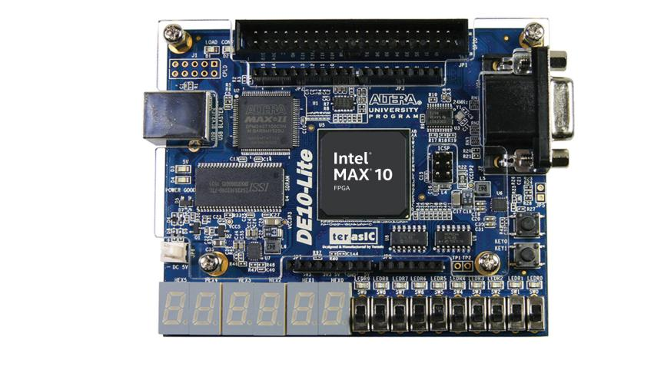

Figure 1: Intel MAX10 FPGA

The connection of the DAC device must match the following figure with the NC port being connected to an available 5V output (labeled as the VCC5 Arduino connection port) with a pin-to-pin wire. Output is observed from the J2 section (top ports) of the DAC, with DAC A being port 6 of J2 and DAC B being port 4. DAC B is connected to ADC output data by default to observe transaction of unfiltered data to the DAC to test function of data transmission between devices. Through MOSI B from pin4 of J1. DAC A is connected to the filtered output data through MOSI A.

Figure : DAC Pin Layout

## Connecting the wave generator and oscilloscope

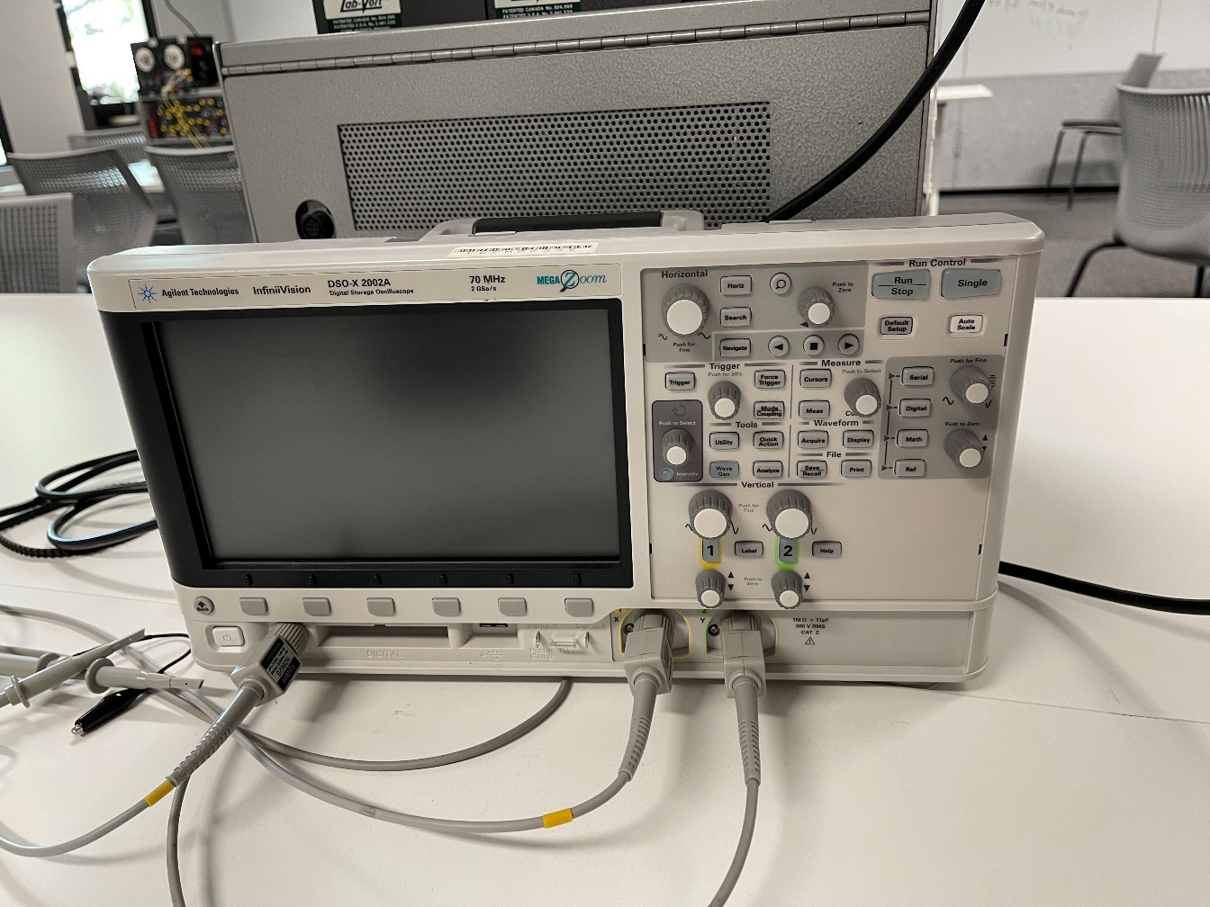

Figure 3: Wave Generator and Oscilloscope

# Operation

## Instructions for Use

After the device is connected as shown in figure 3, turn on the oscilloscope and ensure that you can see both the input and output signal.

By changing the frequency of the input signal, you should be able to see the filter react according to theory and suppress specified frequency bands.

To change the filter coefficients being used, press the first three switches to make a binary number. This lines up with the coefficients in table 1.

## Operating Environment

The device should be used indoors in a normal laboratory environment. The device should not be used in the presence of food or drink, and the device is not IP rated.

## Stopping Operation

Stopping operation of the device is performed by selecting switch 9 of the FPGA to be a logical zero (low). To commence operation put return the switch to the high position.

# Maintenance

## Replacing DAC

The input ports have been designed to GND, NC and I/O 10-13. If DAC part has broken down, users could replace the broken DAC with new one by reconnecting to the ports, shown in figure 2.

# Troubleshooting

Some common errors can be diagnosed and corrected without a professional present.

|  |  |  |  |
| --- | --- | --- | --- |
| # | Error | Cause | Solution |
| 1 | Display error, button and switch failure | FPGA damaged | Go to Control Panel program, which allows users to access various components on the board from a host computer, can download Control Panel program from the web (http://DE10-Lite.terasic.com/cd). |
| 2 | ADC error | No wave signal input | 1.Connect the wave generator with the Oscilloscope directly to see whether it generates waveform, if so  2.Check whether the signal source input is connected to the correct pin corresponding with the VHDL code(default PIN ), if so |
| 3 | FIR error | Coefficient configuration error | 1.Make sure the ADC is working properly, if not, go to #2, if so  2.Check the coefficient you used, whether it isd consistent with the coefficient generated by MATLAB. |
| 4 | DAC error | DAC hardware damaged | 1.Detach the connection between DAC and the other module. Connect the ADC-FIR module with the Oscilloscope directly to see whether it generates waveform, if so  2.check whether the FIR output and the DAC driving code input are connected to the correct pin with corresponding with the VHDL code (default PIN), if so  3.Submit the application of changing the DAC hardware device |
| 5 | No Output on Oscilloscope | An error caused by other Error | 1.Go to #4 |
| 6 | Testing DAC device | DAC is damaged or function is incorrect | The functionality of the DAC can be tested with the designs code. An input mapped to the switches on the FPGA (which is concatenated with four zeros so that it has 12 bits of input for DAC data) is supplied in the chip attributes, the user simply needs to connect the signal to the DAC data input which is provided but commented out for regular function of the design. Once the input is connected the user can observe the output from the relevant port, port 6 for DAC A data output and port 4 for DAC B output on the J2 section of the DAC (top ports of the device). The output should increase with each 1 added to the input (each switch flipped up to input a standard logical 1) with larger increases for more significant bits. A port is also provided for ADC data to be connected directly to the DAC, once ADC function is confirmed this can also be used to ensure functionality of the DAC. It must be noted that for ADC connection, due to the pre-scaler module of the ADC a 2.5V offset must be added to the generated wave supplied to the ADC analogue input port or else the full signal will not be observed by the DAC output. |
| 7 | Testing ADC device | ADC is damaged or function is incorrect | Functionality of the ADC can be tested via the LEDs on the FPGA board. This mapping is done in the chip attributes with the 10 LEDs on the board being assigned to the lower 10 bits of ADC data via the led_out attribute and port. Once connected a DC voltage can be applied to the dedicated analogue input of the ADC (ADCINI0) which is on the far left of the lower right set of the Arduino pins above the switches on the FPGA board. Once connected a response from the LEDs should be observed relative to a rising DC input adjusted with the offset, the resolution of the ADC is 610 micro volts for each discernable quantized level, but the pre-scaler must be considered when observing the output to LEDs. Once this is confirmed to work, the ADC output should be connected to the ADC Register module with the led output mapped to the lower 10 bits of the register data out. The same process to confirm functionality is performed with the DC input and changes to the LEDs, confirming that ADC data can be sent to a module without any issue or loss of data (meaning the state-machine for the ADC handling the data output is working as intended). |
| 8 | Testing of the FIR filter on the device | FIR filters function or set up of modules is incorrect | To test the functionality of the FIR filter on the FPGA device, functionality of the ADC and DAC must be confirmed, respectively. As the filter does not consist of external hardware usage outside of the FPGA like the DAC or is an element that is an internal physical element on the FPGA such as the ADC the function of the filter should be guaranteed by the project. But to confirm that it is functioning the input waveform from the wave generator applied to the dedicated analogue input must be compared with the DAC output that is mapped to filter output (DAC A located on port 6 of the J2 side of the DAC). Changing filters is performed via the two switches zero and one on the FPGA and a message is shown on the seven-segment display to indicate HP for high-pass, LP for low-pass, BP for band-pass and BS for band-stop corresponding to 00,01,10 and 11 by the switch inputs respectively. For each filter is must be confirmed that the data is processed in real time and that the expected function is performed for each filter with bandwidth specifications as per the clients requirements and the hardware limitations (the LPF on the analogue input puts a limit on the usable sampling frequency of filters). |

Table 2: Errors and relevant solutions.

# References

|  |  |
| --- | --- |
| [1] | terasIC, "De10-Lite User Manual," 5 June 2020. [Online]. Available: https://www.terasic.com.tw/cgi-bin/page/archive_download.pl?Language=English&No=1021&FID=a13a2782811152b477e60203d34b1baa.. |
| [2] | Keysight Technologies, "InfiniiVision 2000 X-Series Oscilloscopes Data Sheet," 2021 May 4. [Online]. Available: https://www.keysight.com/au/en/assets/7018-02733/data-sheets/5990-6618.pdf. |
| [3] | Digilent, "PmodDA2 Reference Manual," 24 May 2016. [Online]. Available: https://digilent.com/reference/_media/reference/pmod/pmodda2/pmodda2_rm.pdf. |

# Appendix A – Generating Coefficients

Open the MATLAB filter designer using this command on the MATLAB command line:

filterDesigner

2. The filter designer should have opened on the main screen. Design a lowpass filter using the options given on the main page.

3. Click ‘Design Filter’ at the bottom of the GUI.

4. Go to Filter Arithmetic under the 3rd tab from the top on the left panel.

5. Set the Filter Arithmetic field to Fixed-Point

6. Go to File, then Export, then select these options in the popup, and click the Export button.

7. WRITE STEP EXPLAINING HOW TO PUT COEFFICENTS INTO THE CODE